EX NO 15: Removal of Single-Line and Multi-Line Comments Using LEX

Aim:
To write a LEX program to identify and remove single-line and multi-line comments from a C program and write the resulting program into another file.
Algorithm:
- Start the program.
- Open the input C file and output file.
- Identify single-line comments (//) and multi-line comments (/* */).
- Ignore the comments and copy the remaining program into the output file.
- Close both files.
- Display a success message.
- Stop the program.

Program:

%{
#include <stdio.h>
%}

%%
"//".* ;
"/*"([^*]|\*+[^*/])*\*+"/" ;
.|\n { ECHO; }
%%

int main()
{
extern FILE *yyin, *yyout;
yyin = fopen("program.c", "r");
yyout = fopen("output.c", "w");

if (yyin == NULL || yyout == NULL)
{
printf("File opening error!\n");
return 1;
}

yylex();

fclose(yyin);
fclose(yyout);
printf("Comments removed successfully. Check output.c\n");
return 0;
}

int yywrap()
{
return 1;
}
Sample input:

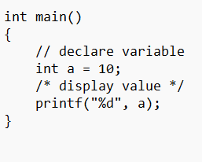
Sample output:
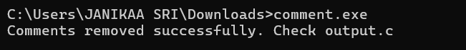

Result:
The LEX program was executed successfully to remove single-line and multi-line comments from the C source program and save the resulting code into another file.

